

Project Report - Database

**Workout and Fitness Tracker App**

By: Rahim Muhammad Syed - (18K-0122)

Abdullah Muzaffar - (18K-0169)

Muhammad Ahmed Khan - (18K-1103)

Instructor: Miss Anam Qureshi

Section: H

Introduction:

Entity Relationship Diagram:

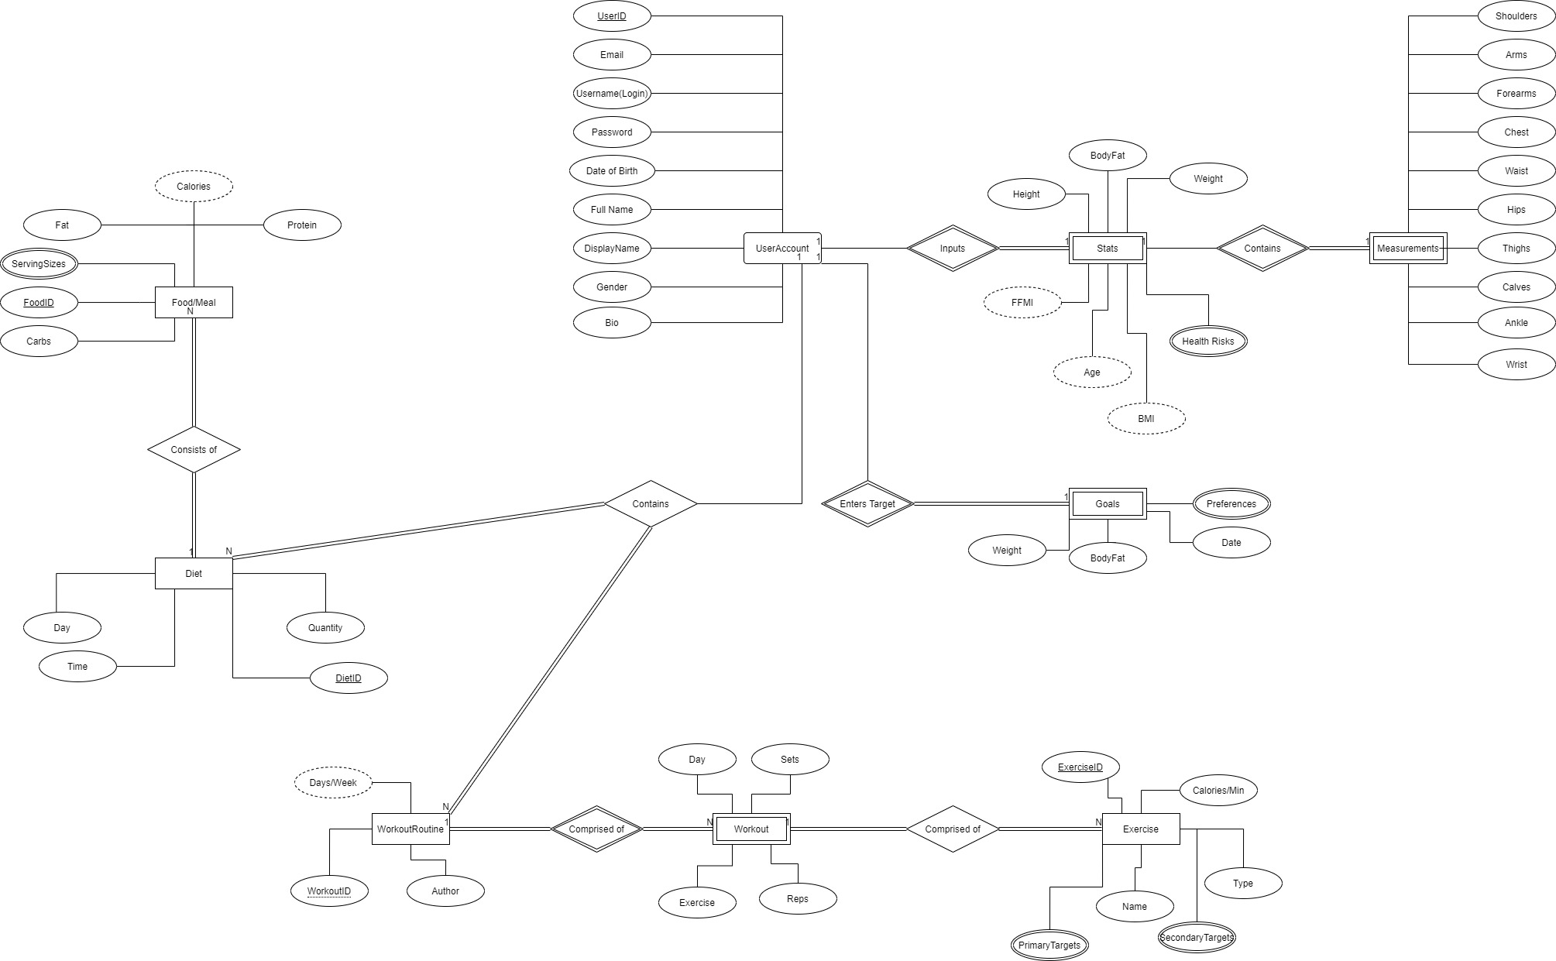

Database Schema Design:

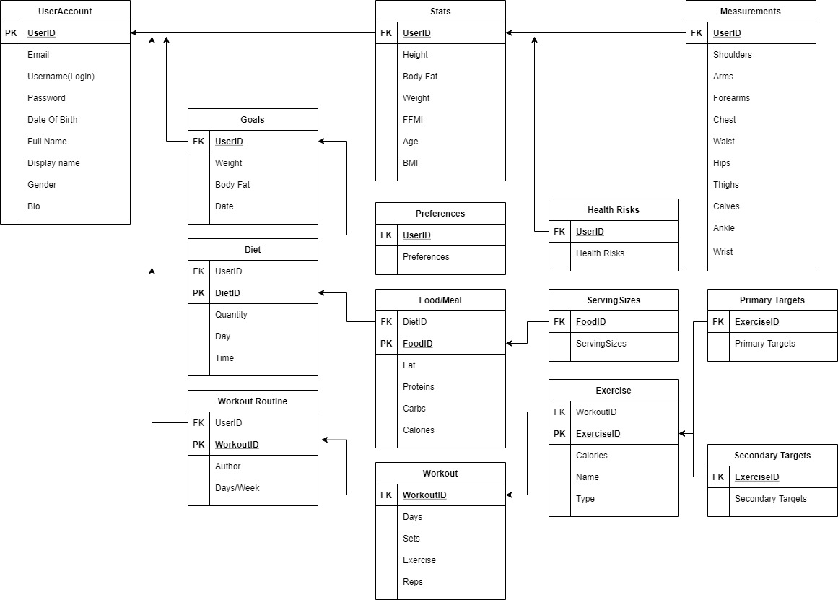

Main Features:

* Signup and Signin

The user data is stored in the form as shown below. Each user is given a unique id and every username is unique in itself. This is done by validation on the frontend which fetches and checks for already existing mail and username in the database.

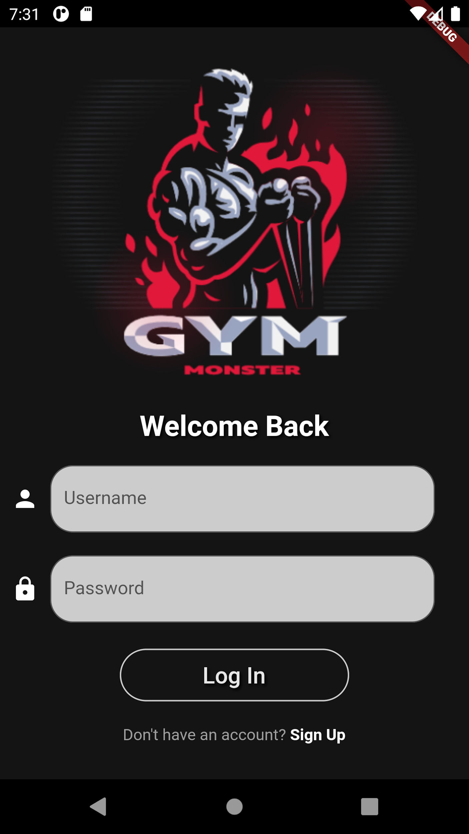 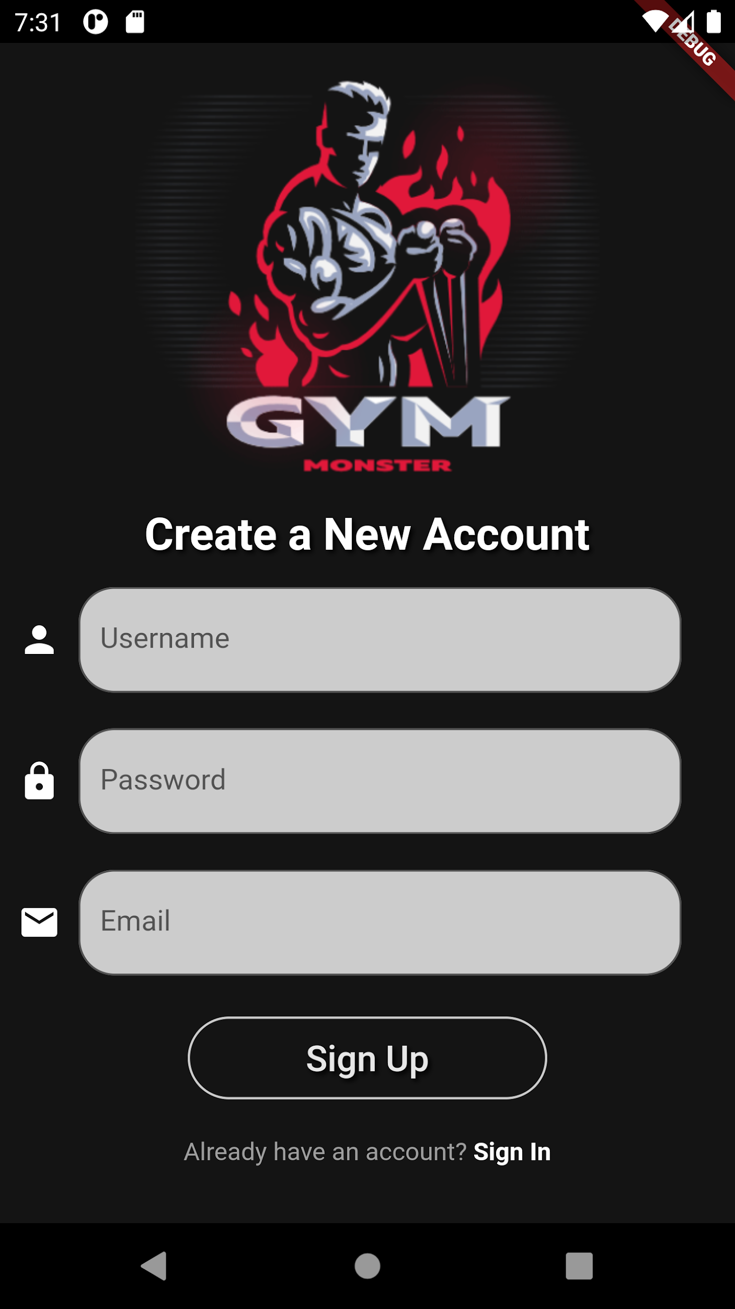

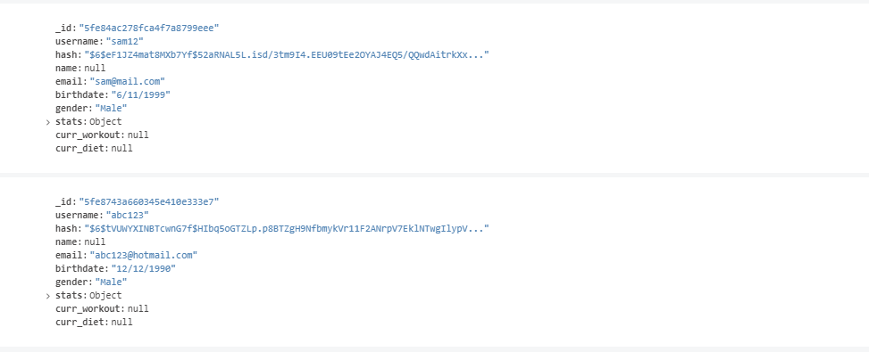

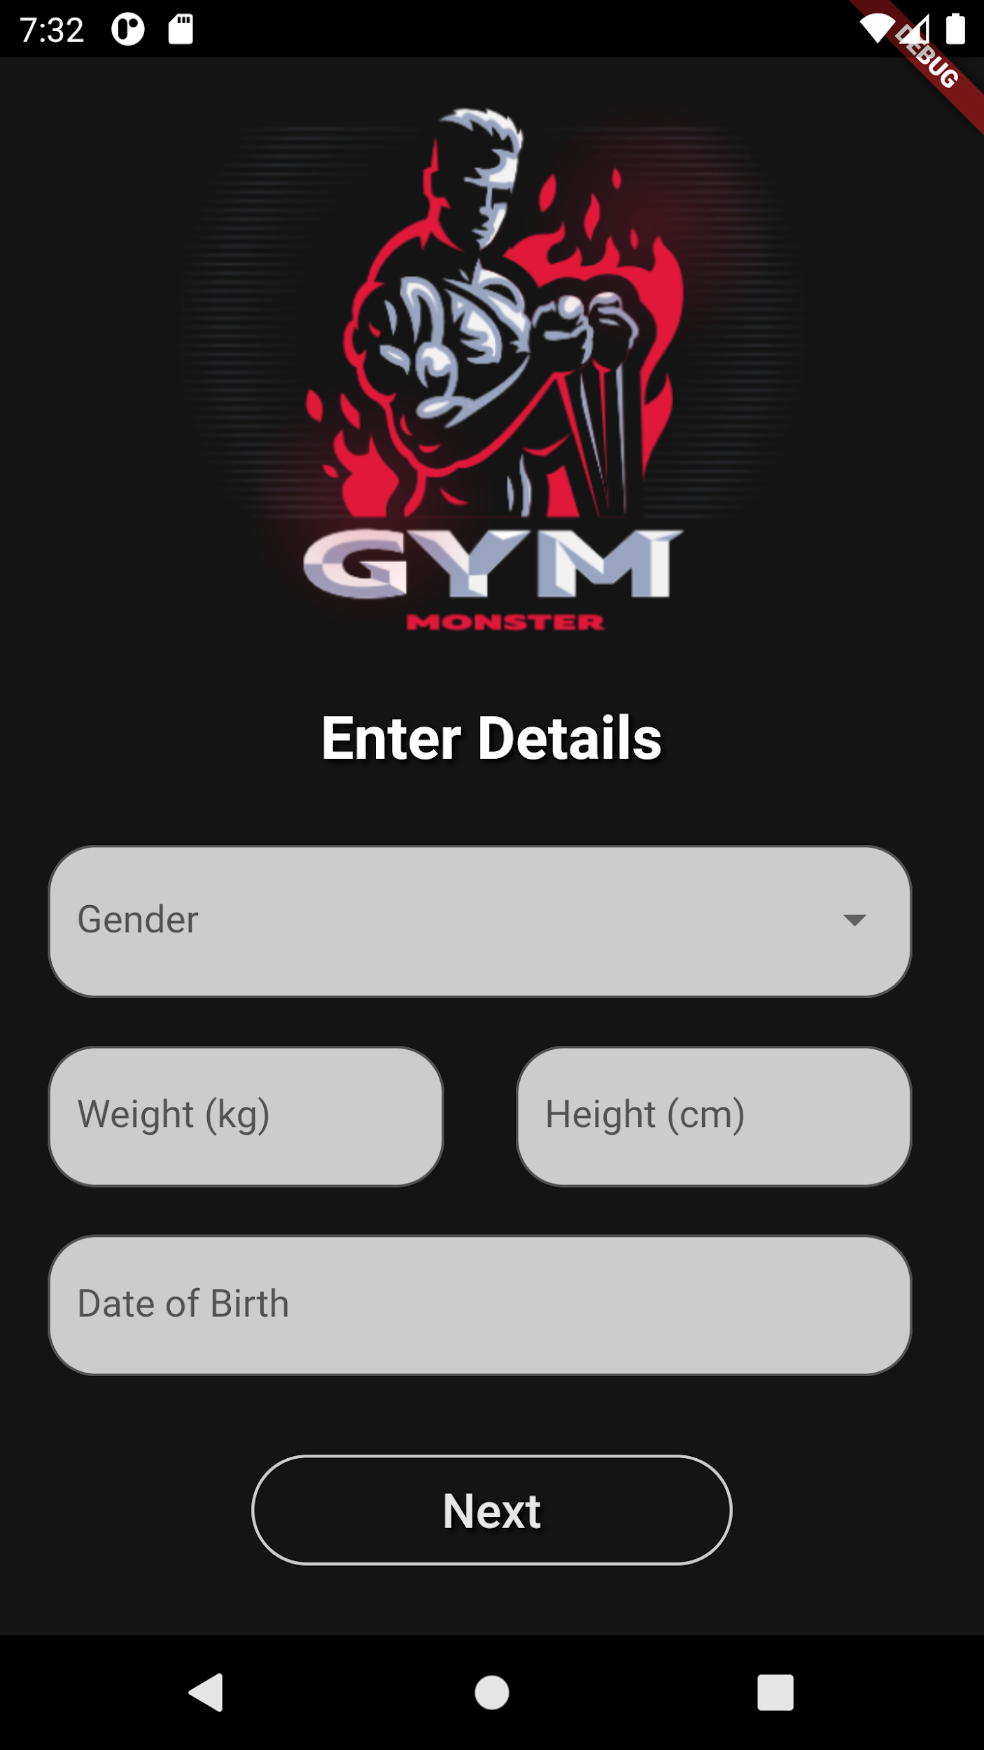 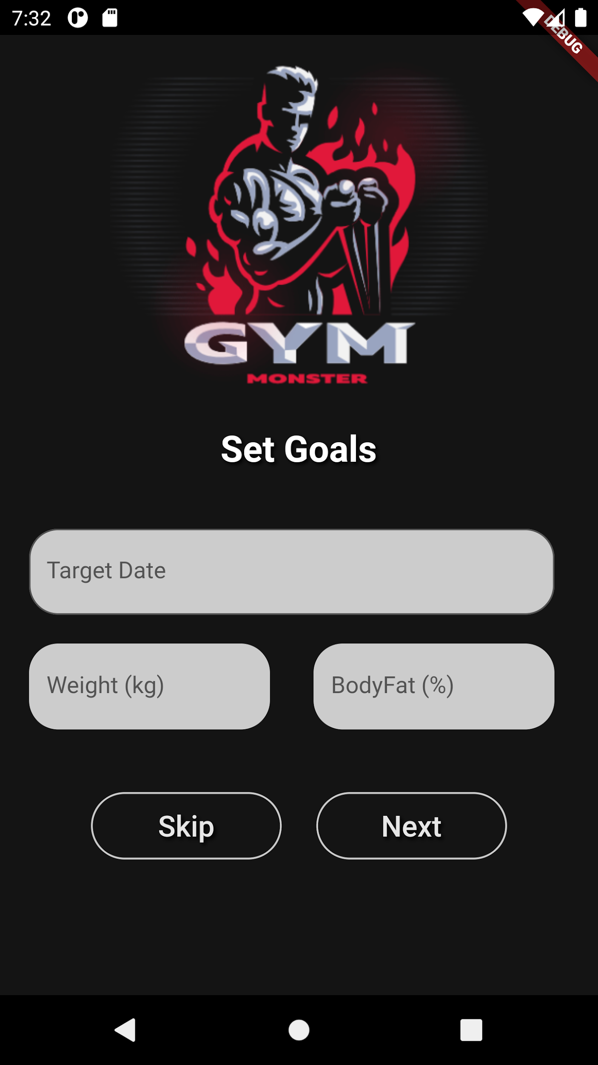

* Once signed in the user is directed to a homepage from where he can navigate throughout the app using the bottom navigation bar.

Technologies Used:

IDE:

* Android Studio/VSCode
* Flutter

Language:

* Dart

DB:

* MongoDB

ERD and Schema Design:

* Draw.io

Challenges and Issue:

* Connecting the database to the application.

Github Link:

* <https://github.com/samuzaffar99/WorkoutTracker>

References:

* <https://stackoverflow.com/>
* <https://www.youtube.com/>
* <https://github.com/>
* <https://medium.com/>
* <https://flutter.dev/>
* <https://pub.dev/>